Hearty Chicken, Sweet Potato, and Apples

* [Nutrition](http://www.teambeachbody.com/teambeachbodyblog/category/nutrition)

* [Recipes](http://www.teambeachbody.com/teambeachbodyblog/category/nutrition/recipes)

13 hours ago

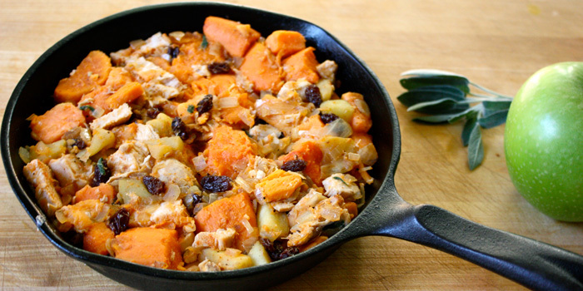

This is a great recipe to use leftover chicken and baked sweet potatoes. Don’t have leftovers? We’ll let you in on a little secret: the dish in the photograph above was made with a chicken breast from the deli section of the supermarket and a bag of frozen cubed sweet potatoes. And it was indeed hearty, and delicious!

**Total Time:** 23 min.  
**Prep Time:** 10 min.  
**Cooking Time:** 13 min.  
**Yield:** 4 servings

**Ingredients:**  
3 tsp. olive oil, divided use  
1 medium onion, chopped  
2 medium tart cooking apples (like Granny Smith or pippin), peeled, cored, finely chopped  
2 cups cubed baked sweet potato, cut into cubes  
¼ cup raisins  
8 oz. cooked chicken breast, boneless, skinless, chopped  
1 tsp. chopped fresh sage  
¼ tsp. sea salt  
¼ tsp. ground black pepper  
¼ tsp. paprika

**Preparation:**  
1. Heat *1½ tsp.* oil in a large nonstick skillet over medium-high heat.  
2. Add onion and apples; cook, stirring frequently, for 6 to 7 minutes, or until mixture begins to brown. Place in a large bowl.  
3. Add potato, raisins, chicken, sage, salt, pepper, and paprika; mix well.  
4. Heat *remaining 1½ tsp.* oil in skillet over medium heat.  
5. Add apple mixture, pat into an even layer in pan; cook, without stirring, for 2 minutes.  
6. Stir gently; cook an additional 2 minutes, or until it begins to brown. Serve immediately.

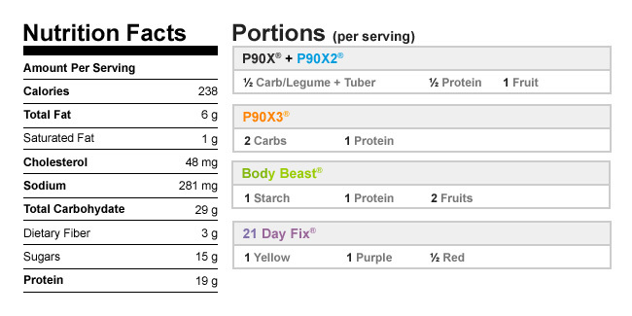

Authors

[Beachbody](http://www.teambeachbody.com/teambeachbodyblog/author/beachbody)

Tags[chicken](http://www.teambeachbody.com/teambeachbodyblog/tag/chicken), [dinners](http://www.teambeachbody.com/teambeachbodyblog/tag/dinners),[lunches](http://www.teambeachbody.com/teambeachbodyblog/tag/lunches), [recipes](http://www.teambeachbody.com/teambeachbodyblog/tag/recipe)

RELATED POSTS